**DAILY ONLINE ACTIVITIES SUMMARY**

|  |  |  |  |  |  |  |  |
| --- | --- | --- | --- | --- | --- | --- | --- |
| **Date:** | **10/06/2020** | | | | **Name:** | **Churashma** | |
| **Sem & Sec** | **4th SEM 'A' Section** | | | | **USN:** | **4AL18CS019** | |
| **Online Test Summary** | | | | | | | |
| **Subject** | | **Object oriented concepts** | | | | | |
| **Max. Marks** | | **30** | | **Score** | | **22** | |
| **Certification Course Summary** | | | | | | | |
| **Course** | **Introduction to Ethical hacking** | | | | | | |
| **Certificate Provider** | | | **greatlearning academy** | **Duration** | | | **4.0 hours** |
| **Coding Challenges** | | | | | | | |
| **Problem statement 1: Write a C Program to print the sum of boundary elements of a matrix.**  **Problem statement 2 : Write a Java Program to find total number of subarrays which start and end with the same element.**  **Problem statement 3: Write a java program to count all the triplets such that sum of two elements equals the third element.**  **Problem statement 4: Java Program to find the longest repeating sequence in a string**  **string:acbdfghybdf** | | | | | | | |
| **Status: completed** | | | | | | | |
| **Uploaded the report in Github** | | | | **yes** | | | |
| **If yes Repository name** | | | | **https://github.com/Churashma/Lockdown-coding** | | | |
| **Uploaded the report in slack** | | | | **yes** | | | |

ONLINE TEST DETAILS: OOC test was scheduled from 09:15 am to 09:45am .The portion for the IA was module 3 and module 4 there were 15 questions and the time assigned was 30 minutes the questions were mcq type.

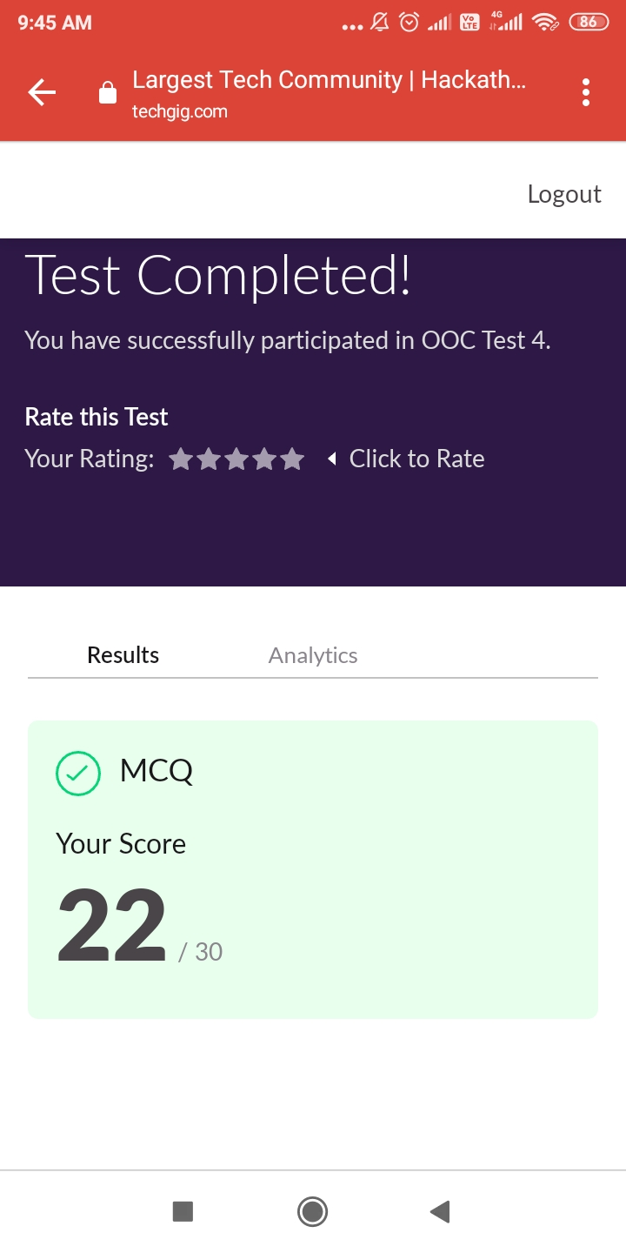

CERTIFICATION COURSE DETAILS: Today I studied about what is ethical hacking.Ethical Hacking is an authorized practice of bypassing system security to identify potential data breaches and threats in a network. Ethical hackers aim to investigate the system or network for weak points that malicious hackers can exploit or destroy.Then I completed watching all the videos of ethical hacking then I attended quiz of ethical hacking and I got certificate.

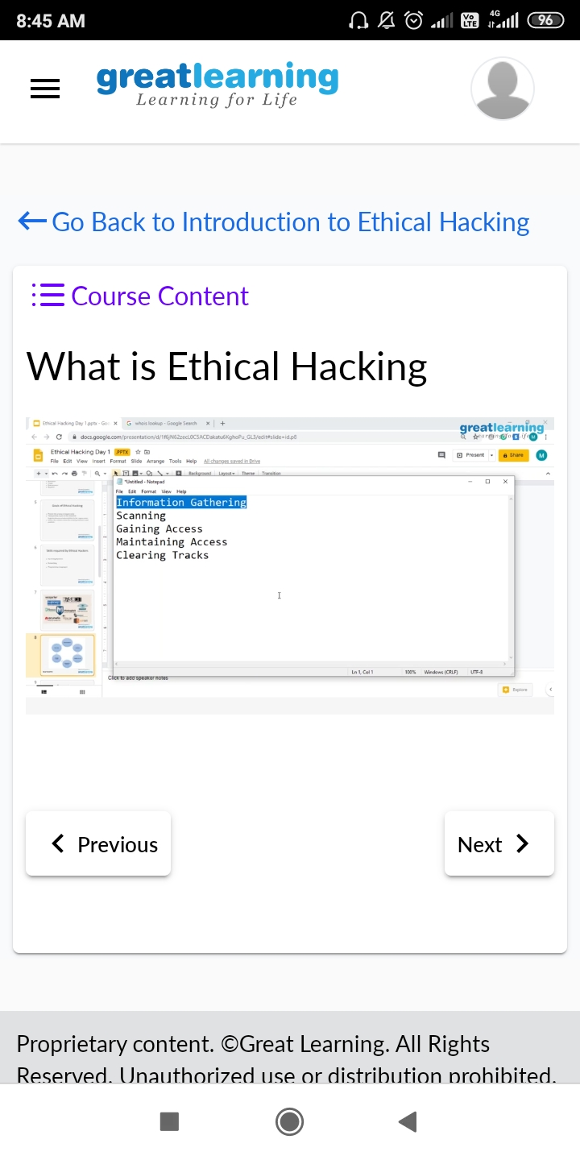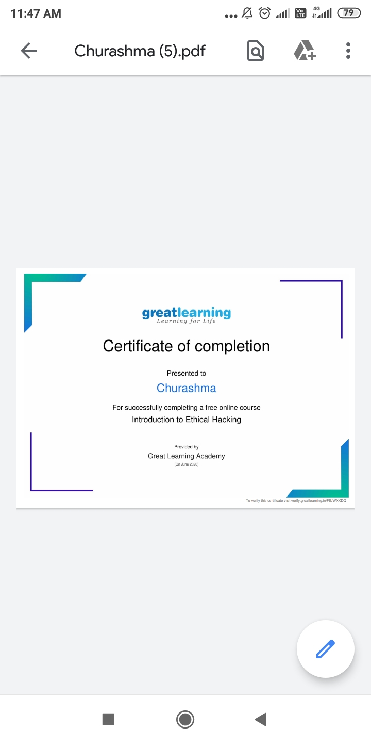

**CODING CHALLENGES DETAILS**:

**Problem statement 1:** Write a C Program to print the sum of boundary elements of a matrix

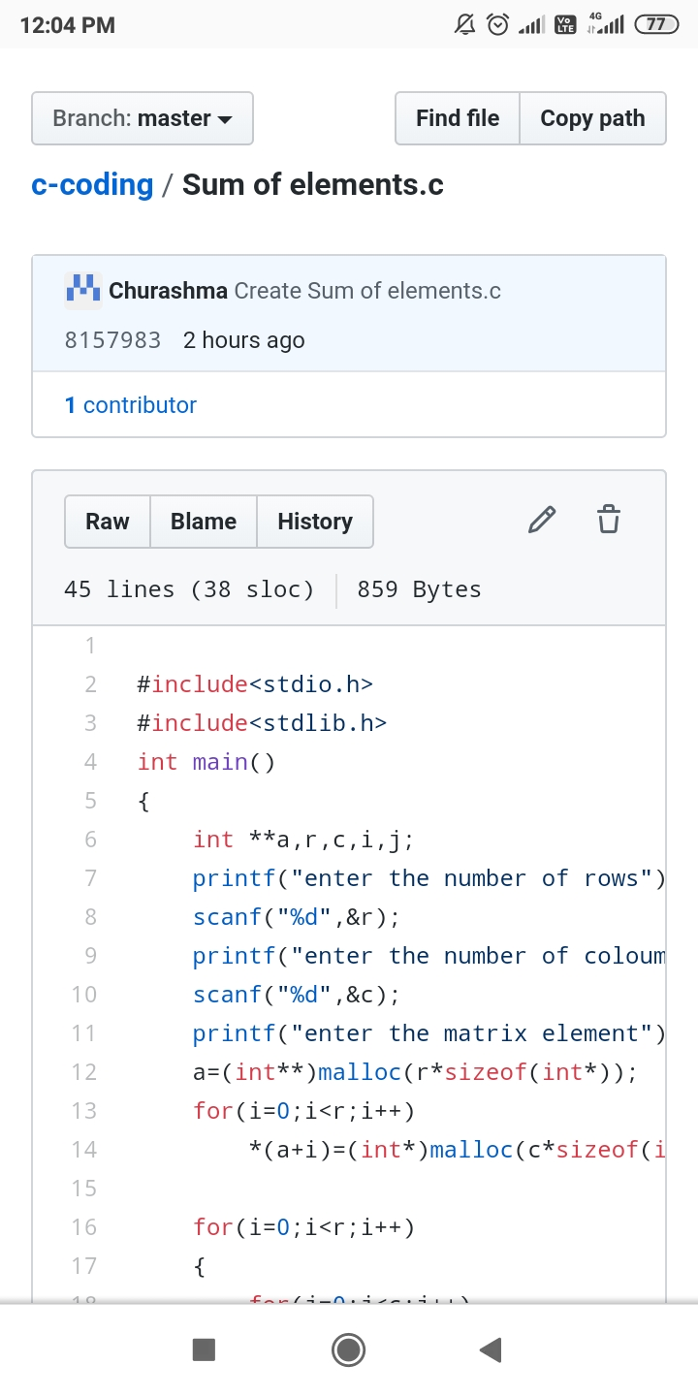

**Problem statement 2:** Write a Java Program to find total number of subarrays which start and end with the same element.

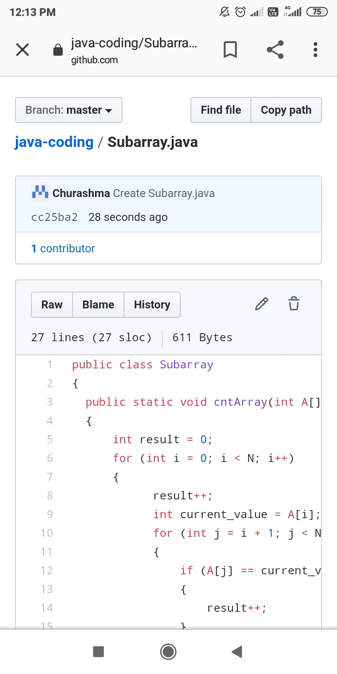

**Problem statement 3**: Write a java program to count all the triplets such that sum of two elements equals the third element.

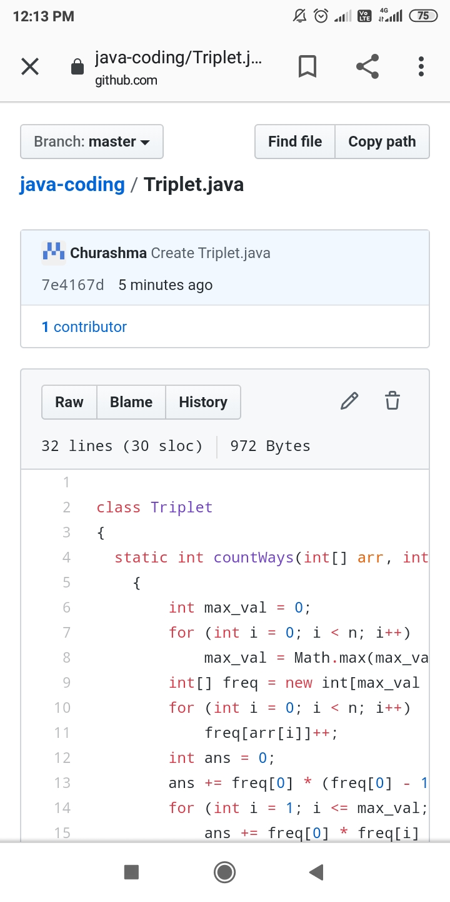

**Problem statement 4**: Java Program to find the longest repeating sequence in a string

string:acbdfghybdf

